48

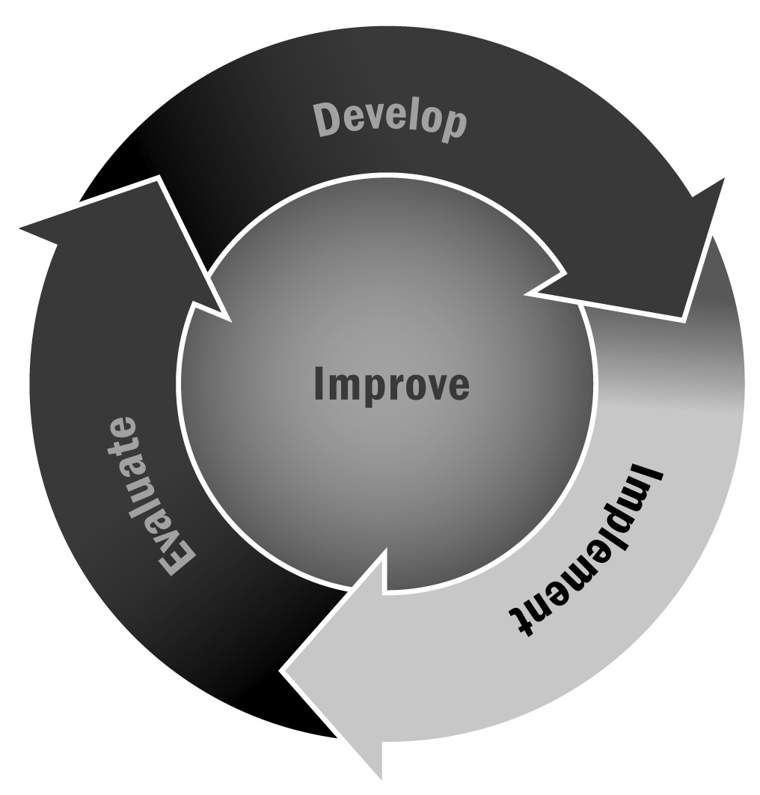
School Staff Meeting Topics
In Chapter 3, you learned that it is important to involve the school day staff in the afterschool and expanded learning program. Keeping school personnel in the loop and also providing them the opportunity to weigh in on program goals helps forge positive relationships. Staff meetings are a great time to update school staff members and get their input on what is happening in the program.
Directions: Below are some specific topics you might want to address at a school staff meeting. Don’t try to talk about everything at once. Instead, pick one topic to cover per meeting. Share information about your program and then ask for input from school staff.

Homework Help
Information to share/discuss:
- The goal of the homework assistance program
- Whether participation in homework assistance is optional, mandatory for all, or mandatory for some young people
- How staff members know what students’ homework assignments are (e.g., youth tell them, they are notified by school day teachers, assignments are written in a planner)
- How staff members are told to help youth who are struggling with specific homework concepts (e.g., try to clarify the problem, urge the young person to note on the homework what he or she does not understand and share that information with the school day teacher)

Enrichment Activities
Information to share/discuss:
- The goal of the enrichment program
- Whether participation in enrichment is optional or mandatory
- How recruitment happens for enrichment (e.g., by registration/sign-up, through referral, on a drop-in basis)
- The types of enrichment activities offered (e.g., art, drama, music, dance, photography; cooking, woodworking, sewing, arts and crafts; computer lab; STEM; health and wellness)
- How the program chooses what kinds of enrichment activities to offer (e.g., based on activity leader interest/talent; youth interest, school staff member interest)
- School staff members’ ideas for enrichment and how enrichment can support the school day

Academic Content
Information to share/discuss:
- Types of academic content the program covers
- How the program connects with school day teachers to identify appropriate content (e.g., conversations with school administration, notes from teachers, etc.)
- Areas of greatest concern/need for student improvement

Use of Physical Space
Information to share/discuss:
- Needs for classroom and other space (e.g., library, computer lab, gym, cafeteria)
- How teachers would like their classrooms kept (e.g., policies about use of boards, desk rearranging)
- Goals for use of space (e.g., desire to hang student work from the program, need for program ownership in school)

